

**“FINDING MEASUREMENTS OF AN OBJECT WITHIN AN IMAGE USING MATLAB”**

**A MINIPROJECT REPORT**

***Submitted by***

**C KEERTHI – 1NH18EC708**

**J AKHIL KUMAR – 1NH18EC137**

**K KABILAN – 1NH18EC721**

**SOURABH SRIKUMAR– 1NH18EC749**

***In partial fulfillment for the award of the degree of***

BACHELOR OF ENGINEERING

**IN**

**ELECTRONICS AND COMMUNICATION**

## NEW HORIZON COLLEGE OF ENGINEERING

## DEPARTMENT OF ELECTRONICS AND COMMUNICATION ENGINEERING



**CERTIFICATE**

Certified that the mini project work entitled “**FINDING MEASUREMENTS OF AN OBJECT WITHIN AN IMAGE USING MATLAB**” carried out byC KEERTHI (1NH18EC708), J AKHIL KUMAR(1NH18EC137), K KABILAN(1NH18EC721), SOURABH SRIKUMAR( 1NH18EC749) bonafide students of Electronics and Communication Department, New Horizon College of Engineering, Bangalore.

The mini project report has been approved as it satisfies the academic requirements in respect of mini project work prescribed for the said degree.

Mini Project Guide: HOD ECE

MS.Lipsa Dash Dr. Sanjeev Sharma

Senior Assistant Professor B. Tech, M.Tech, Ph.D

Department of Electronics and Communication

------------------------- -------------------------

**External Viva**

Name of Examiner Signature with Date

1.

2.

**ABSTRACT**

# **“FINDING MEASUREMENTS OF AN OBJECT WITHIN AN IMAGE USING MATLAB”**

# In today’s Digital World, there are many digital applications that help us take pictures and videos of the beautiful nature. With the help of our project, we can use these images to measure the dimensions such as length of those objects. We use the software MATLAB to accomplish this certain objective.

# As technology is rapidly changing and improving due to the massive usage of various instruments we have designed a code with the help of MATLAB which helps in finding the parameters of an object by only using it image. This helps in finding any parameters(big/small) easier as we only the image of the machine.

# MATLAB is a high-level language and interactive environment for computer computation, visualization, and programming. Image Processing Toolbox is an application available for use in MATLAB, which provides a comprehensive set of reference-standard algorithms, functions, and apps for image processing, analysis, visualization, and algorithm development. Using these tools provides a fast and convenient way to process and analyze images without the need for advanced knowledge of a complex coding language.

# The functions in matlab are very simple are easy to understand and easy to applicable which makes it easy for one to apply this and make use of this project.

**ACKNOWLEDGEMENT**

The satisfaction that accompany the successful completion of any task would be, but impossible without the mention of the people who made it possible, whose constant guidance and encouragement helped us succeed.

I thank **Dr. Mohan Manghnani**, Chairman of **New Horizon Educational Institution**, for providing necessary infrastructure and creating good environment.

I also record here the constant encouragement and facilities extended to us by **Dr.Manjunatha**, Principal, NHCE and **Dr. Sanjeev Sharma**, head of the department of Electronics and Communication Engineering. We extend sincere gratitude to them.

I sincerely acknowledge the encouragement, timely help and guidance to us by our beloved guide **Ms. Lipsa Dash** to complete the project within stipulated time successfully.

Finally, a note of thanks to the teaching and non-teaching staff of electronics and communication department for their co-operation extended to us, who helped us directly or indirectly in this successful completion of mini project.

**C Keerthi (1NH18EC708)**

**J Akhil Kumar (1NH18EC137)**

**K Kabilan (1NH18EC721)**

**Sourabh Srikumar (1NH18EC0749)**

**TABLE OF CONTENTS**

ABSTRACT

## **CHAPTER 1**

INTRODUCTION ………………………………………………………………………………07

## **CHAPTER 2**

LITERATURE SURVEY………………………………………………………………………17

## **CHAPTER 3**

EXISTING SYSTEM AND PROBLEM STATEMENT………………………………………18

## **CHAPTER 4**

PROPOSED METHODOLOGY………………………………………………………………………………19

**CHAPTER 5**

PROJECT DESCRIPTION………………………………………………………………………………………..20

## **CHAPTER 6**

RESULT AND DISCUSSION………………………………………………………………….25

**CHAPTER 7**

ADVANTAGES AND APPLICATION…………………………………………………….....29

**CHAPTER 8**

CONCLUSION AND FUTURE SCOPE………………………………………………………30

REFERENCE

**LIST OF TABLES**

1. Table 1.1: Literature Survey………………………………………………………………..17

# **LIST OF FIGURES**

* + 1. Fig:1.1 11
    2. Fig :1.2 12
    3. Fig 1.3: 12
    4. Fig 1.4: ……………………………………………………………......................................12
    5. Fig 1.5 13
    6. Fig 1.6 14
    7. Fig 1.7 15
    8. Fig 1.8 22
    9. Fig 1.9: 26
    10. Fig 2.0: 26
    11. Fig 2.1: 27
    12. Fig 2.2: 28

**CHAPTER 01**

**INTRODUCTION**

* Measuring objects in an image or frame is an important skill for many applications that require computer vision rather than physical dimensions.
* Matlab allows you to manage mapping of data, functions, and arrays, implement algorithms, create user interfaces, and interact with programs written in other languages.
* Measuring objects in an image or frame is an important skill for many applications that require computer vision rather than physical dimensions.
* Application Note This application contains a basic step-by-step algorithm to isolate the object that the application requires and measure its length.
* Matt Lab is a highly interactive environment for computing, visualization, and programming.
* M Image Processing Toolbox is an application available for use in Matlab with a complete set of algorithms, functions, and standard reference applications for image algorithm development, analysis, visualization and processing.

Digital image processing is used to create, connect, process, and display digital images using some computer algorithms. A digital image processing algorithm can be used to convert image sensor signals into digital images. Improve clarity, remove noise and other portable objects. Extract the scale, size, or number of objects in a scene. It has many advantages over analog image processing and allows more advanced algorithm to be applied to data entry, avoiding problems such as noise and distortion during processing.

Image processing appears to uncontrollably manipulate the image to achieve aesthetic quality or to support reality. Unlike digital detectors, the human eye does not see the world and display devices impose additional controls for noise and bandwidth. The image is usually filled with some kind of distortion and noise that must be removed from the image in order to get the correct image, which is achieved by means of filter techniques.

In this project we are trying to implement some filtering techniques for image processing to get a clear image without any kind of noise or distortion. This project uses 3 main filters, namely fish filter, median filter and adaptive median filter. The results of these filters are viewed and analyzed using two parameters, Peak Signal-to-Noise Ratio (PSNR) and Fish Square Error (MSE).

Digital image processing is a more focused area for human comprehension, free transfer of updated multimedia data, and analysis of image information for machine perception capabilities, transmission, and representation. In general, the digital image query steps can be followed and the workflow statement of Digital Image Processing (DIP) can be displayed in Figure 1. Figure 1: Block diagram of digital image processing Image acquisition The initial stages of digital image processing At this stage the image experiences pre-processing, i.e. scaling. The main goal of preprocessing techniques is to improve the image quality, reduce unnecessary distortions and improve the quality of the input image. Feature extraction starts with a set of measured information, and fabricates certain values ​​that are planned as instructive and unresponsive, facilitating subsequent learning and generalization processes and now inducing better human interpretations.

## **Image processing**

Image processing is the process of converting an image into a digital format in order to achieve better performance or extract some useful information from it. Changes in images are usually based on carefully designed automated algorithms.

Image processing is an interdisciplinary field with contributions from various disciplines of science, including mathematics, physics, and optical and electrical engineering. It overlaps with areas such as pattern recognition, machine learning, artificial intelligence, and human vision research.Image processing involves importing an image from a scanner or digital camera, analyzing and manipulating the image (data compression, image optimization, filtering), and creating the desired output output image.

Extracting information from images and interpreting their contents is the driving force behind the development of image processing. Image processing finds use in many fields, including medicine, industry, military, and consumer electronics.

In medicine, diagnostic methods such as digital radiography, positron emission tomography (PET), computerized axial tomography (CAT), magnetic resonance imaging (MRI), and functional magnetic resonance imaging (FMRI) are used. Industrial applications include manufacturing systems such as safety systems, quality control, and directed automated control in a vehicle.

Sophisticated image processing algorithms are used in applications ranging from military or vehicle detection to missile navigation, object detection and intelligence. Biometric techniques, including fingerprinting, face, iris, and hand recognition, are widely used in law enforcement and security.

Digital cameras, camcorders, high-definition televisions, monitors, DVD players, personal video recorders, and mobile phones are common consumer electronics with image processing.

In general, image processing is the processing of information to enhance or extract information from an image. There are two methods of image processing:

Physical Analog image processing is used to process physical photographs and other prints and paper copies of photos.

Digital image processing is used to process digital images with the help of computer algorithms.

Anyway, the entry is a picture. For analog image processing, the output is always the image. However, for digital image processing, the output can be an image or information related to that image, such as data about features, properties, binding boxes or masks.

**Related services**

Artificial Intelligence Development Services

Today, image processing is largely used in medical visualization, biometrics, self-driving vehicles, gaming, surveillance, law enforcement, and other fields. Here are the main purposes of image processing:

Visualization - Represents the processed data in an understandable way, for example giving visual form to invisible objects

Sharp image sharpening and restoration - improve the quality of processed images

Ret Image Recovery - Image Search Assistance

Me Object Object - Measure the objects in an image

Tern pattern recognition - sort and sort objects in an image, identify their positions, and understand the scene

HISTORY

By 1990, 4 variants of Matlab were included in the picture show. Many attentive clients found that the default pixel impression of a low-level picture show object. Overall, in case you called the image without any information controversy, it will show a smaller image. When you were a Matlab 4 client, you may have seen something like this:

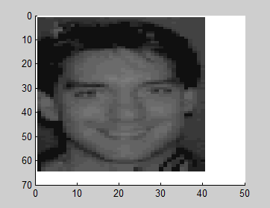

**Fig.1.1**

When MATLAB 5 was released, some users noticed that the default image had changed.

image

colormap(gray(32))

axis ij

**Fig.1.2**

A few users also noticed that the pixel values in the new default image were not integers.

h = findobj(gcf,'type','image');

cdata = get(h,'CData');

cdata(1:3,1:3)

*ans =*

*11.2307 12.4251 10.4251*

*14.4251 15.7483 13.7483*

*12.3938 13.7483 12.7483*

**Fig.1.3**

Is there something interesting about the fractional part?

imagesc(cdata - floor(cdata))

**Fig.1.4**

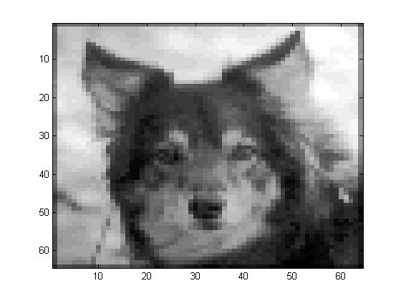

**Fig.1.5**

Evidently so.

I currently agree - you can blame me for all this. I unexpectedly told this story a week ago at the IEEE International Conference on Image Processing in Atlanta, GA. Currently, every user's favorite blog, you can listen to it too.

At the end of 1993 I joined Math Works. At one point in 1994, the organization closed its first representative foundation. The "Things" set for the offer is the option to select the default image for MATLAB 5, which has been running since. While developing the new "Image Maker", I felt some obligation. (Anyway, this is the way I tried to reveal my half later.) By the end of it, another MathWorks designer really needed this thing to succeed, so I paid oodles to get it. (This supports good cause, and I continue to remind myself.)

When I get bartering, I have to choose which image to choose. During this time, I often heard murmurs from clients that Matlab could handle double accuracy calculations. (That continued until 1997.) Having heard so much about this issue, I concluded that the entire Mantiza bits would be used for the new default image. I requested thoughts from my cousin engineers on what to include.

Here are the different pictures "covered up" in various piece cuts of the default picture pixel esteems. (To run the code yourself, download this little utility capacity, bit slice.)

The picture put away in the 5 most-critical pieces is the one you normally observe. This is my friend.

defimage = pow2(get(0,'DefaultImageCData'),47);

mag = 200;

imshow(bitslice(defimage,47,51), 'initialmag', mag);

**Fig.1.6**

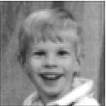

**Fig.1.7**

#### IMPORTANCE

#### Digital image processing is the use of a digital computer to process digital images through an algorithm. As a subfield or field of digital signal processing, digital image processing has many advantages over analog image processing. This allows you to apply a more advanced algorithm to the input data and avoid problems such as amplification and distortion during processing. Because images are defined in two dimensions (perhaps more), digital image processing can be modeled in the form of multidimensional systems. The production and development of digital image processing is mainly influenced by three factors: first, the development of computers; Second, the development of mathematics (especially the creation and improvement of a particular mathematical theory); Third, there is a growing demand for extensive applications in the environmental, agricultural, military, industrial, and medical sciences.

#### Agriculture:

#### In the current situation, due to the large density of the population, the demand for food, the scarcity of agricultural land, environmental change and political instability are having dire consequences, and the agro-industries are trying to find new solutions to increase its essence of productivity and sustainability. Accurate farming is used to meet and meet the needs of farmers. It will enable farmers to innovate their farming practices by using data innovation tools that enable them to listen, evaluate and control agricultural practices such as the use of adequate amounts of fertilizers, pesticides and water. Identifies crop detection and seed identification. Precision agriculture is an innovative technology that leads to the integration of developing technologies to improve agricultural production and enrich the farm with different types of agricultural data. Data Resolution Accuracy Crop Yield High Low Topographic High Medium Soil Sample Low High Artisan A system based on computer based image analysis has been developed. Determines the ratio of crops, weeds and soil in the picture. Different types of light, soil background structure, crop growth including crop growth stage and weed size are considered as barriers to image cultivation.

#### CHAPTER 02

**LITERATURE SURVEY**

|  |  |  |  |
| --- | --- | --- | --- |
| **Title of the paper** | **Author & Year of Publication** | **Outcome** | **Limitation** |
| **Image processing** | Matthew Wesolowski  November, 2014 | Gives all the info regarding how to process an image. | Gives info only about image processing. |
| **IMPORTANCE OF IMAGE ENHANCEMENT TECHNIQUES IN COLOR IMAGE SEGMENTATION: A COMPREHENSIVE AND COMPARATIVE STUDY** | Dibya Bora  April, 2017 | Gives an idea on image enhancement and image segmentation. | Not applicable if object and background are of same color. |
| **Image Segmentation Algorithms Overview** | Song Yuheng1 & Yan Hao1 | Gives a very brief idea on image segmentation, color and edge segmentation. | The research of image segmentation theory is not perfect, and there are still many practical  problems in applied research |

**Table 1.1 Literature Survey**

**CHAPTER 03**

**EXISTING SYSTEM AND PROBLEM STATEMENT**

**Existing Systems:**

* System The current system has bad voice cancellation.
* Object It is difficult to identify the desired object from the background.
* Object shapes are limited.

**Problem Statement:**

* And how to find the dimensions of a large and heavy object??
* A We cannot physically find the length from an image because it is tedious, so we use MATLAB and calculate the length from an image.
* Application Note This application contains a basic step-by-step algorithm for separating the required object and measuring its length.

**Objectives:**

With this application note you can write a matlab script file to import an image, segment the image, extract the desired object from its background and use the matlab functions that come with the image processing toolbox.

**CHAPTER 04**

**PROPOSED METHODOLOGY**

* Instruments As technology changes and improves rapidly due to the extensive use of various tools, we have designed a code with the help of MattLab to find the parameters of an object using an image.

* It makes it easy to find any parameters (large / small) as we only need the image of the object.
* There is no need to be physically present to measure the parameters of the para object.
* It makes it easier for us to find the parameters of large objects.

**CHAPTER 05**

**PROJECT DESCRIPTION**

INPUT

Read Image

Convert image to black and white

Measuring length

Choose Pixels ,cm and m

Print “Length = %0.2f pixel”

Print “Length = %0.2f cm”

Print “Length = %0.2f m”

**T**

**F**

If u=1

If u=2

OUTPUT

**Hardware specifications:**

* Operating System: Windows XP or better, Mac OS X Lion or better.
* Processors: Intel or AMD Raison x86 processor.
* Disk space: 4GB or better RAM: 2048 MB Minimum recommended.
* Graphics Card: The hardware accelerated graphics card that supports OpenGL 3.3 recommends 1GB of GPU memory.

**Windows XP:**

Windows XP is an operating system developed by Microsoft as part of the Family Operating System. It was the successor to Windows 2000 for professional users and Windows Mi for home users.

The development of Windows XP began in the late 1990s under the name "Neptune", an operating system (OS) built into the Windows NT kernel specifically intended for mainstream consumer use. The updated version of Windows 2000 was also originally intended for the business market; However, in January 2000, both projects dropped the single name "Whistler" in favor of the OS, which would serve as a single OS platform for the consumer and business markets. Windows XP was the first consumer version of Windows based on MS-DOS

**Software specifications**

* MATLAB 2014a.
* Image Processing Toolbox.

**MATLAB**

* (an abbreviation of "matrix laboratory") is a [proprietary](https://en.wikipedia.org/wiki/Proprietary_software) [multi-paradigm](https://en.wikipedia.org/wiki/Multi-paradigm_programming_language) [programming language](https://en.wikipedia.org/wiki/Programming_language) and [numeric computing](https://en.wikipedia.org/wiki/Numerical_analysis) environment developed by [MathWorks](https://en.wikipedia.org/wiki/MathWorks). MATLAB allows [matrix](https://en.wikipedia.org/wiki/Matrix_(mathematics)) manipulations, plotting of [functions](https://en.wikipedia.org/wiki/Function_(mathematics)) and data, implementation of [algorithms](https://en.wikipedia.org/wiki/Algorithm), creation of [user interfaces](https://en.wikipedia.org/wiki/User_interface), and interfacing with programs written in other languages.
* Although MATLAB is intended primarily for numeric computing, an optional toolbox uses the [MuPAD](https://en.wikipedia.org/wiki/MuPAD) [symbolic engine](https://en.wikipedia.org/wiki/Computer_algebra_system) allowing access to [symbolic computing](https://en.wikipedia.org/wiki/Symbolic_computing) abilities. An additional package, [Simulink](https://en.wikipedia.org/wiki/Simulink), adds graphical multi-domain simulation and [model-based design](https://en.wikipedia.org/wiki/Model-based_design) for [dynamic](https://en.wikipedia.org/wiki/Dynamical_system) and [embedded systems](https://en.wikipedia.org/wiki/Embedded_system).
* As of 2020, MATLAB has more than 4 million users worldwide.[[20]](https://en.wikipedia.org/wiki/MATLAB#cite_note-mathworksCompanyOverview-20) MATLAB users come from various backgrounds of [engineering](https://en.wikipedia.org/wiki/Engineering), [science](https://en.wikipedia.org/wiki/Science), and [economics](https://en.wikipedia.org/wiki/Economics).

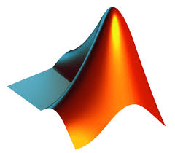

**Fig.1.8**

**IMAGE PROCESSING TOOL:**

* Process Image Processing Toolbox provides comprehensive benchmark algorithms and workflow applications for image processing, analysis, visualization, and algorithm development.
* Image You can do image segmentation, image enhancement, volume reduction, geometric transition, image recording and 3D image processing.
* Image Image Processing Toolbox Applications allow you to automate standard image processing workflows. You can interactively split image data, compare image recording techniques, and process large data sets.
* Visualization functions and applications allow you to explore 3D images, volumes, and videos. Visual acuity control, graphic creation, and manipulation of areas of interest (ROIs).
* You can speed up your algorithm by running it on multi-core processors and GPUs. Supports several toolbox functions for generating C / C ++ code for desktop prototypes and deploying an embedded visibility system.

**Segmentation:**

* Converts 2D image in RT color space to 3D matrix in AT Matlab. The function of the code (imread) converts 2D into a 3D matrix.
* RGB stands for red, green, and blue contrast levels. After converting the image to RGB color space, it is divided into binary images to distinguish the background from the desired object.
* Then color separation of red, green and blue is done. Thresholding takes an intensity image and converts it to a binary image at the desired level.
* We need to choose a value between 0 and 1 that corresponds to the pixel rate for our object.
* All After this we can see that the image is divided between the object and the background.
* More Significantly clean all sounds to get more accurate measurements. The image we now get is called a blob.
* Blobs are any collection of white pixels that are touched to create an attractive and distinctive object.

**Measurement:**

* The result of all the segmentation and clean up procedures gives a distinct and attractive blob that represents the object in the original photo.
* Now that we are in the image binary, it makes it easier for other functions in Matlab to quickly analyze the area and host other information.
* Use the function to measure the main axis of the blob (region props).
* MATLAB has other functions similar to measuring other parameters of an object.

**CHAPTER 06**

**RESULT AND DISCUSSION**

* The length is now approximately displayed in the command window. 170 pixels across. This was checked using the (Imdistline) function.
* Figures As we can see between the two figures, the estimated value of the code was very close to the manual measurement.
* This software measures the length of an object.

**Output Images**

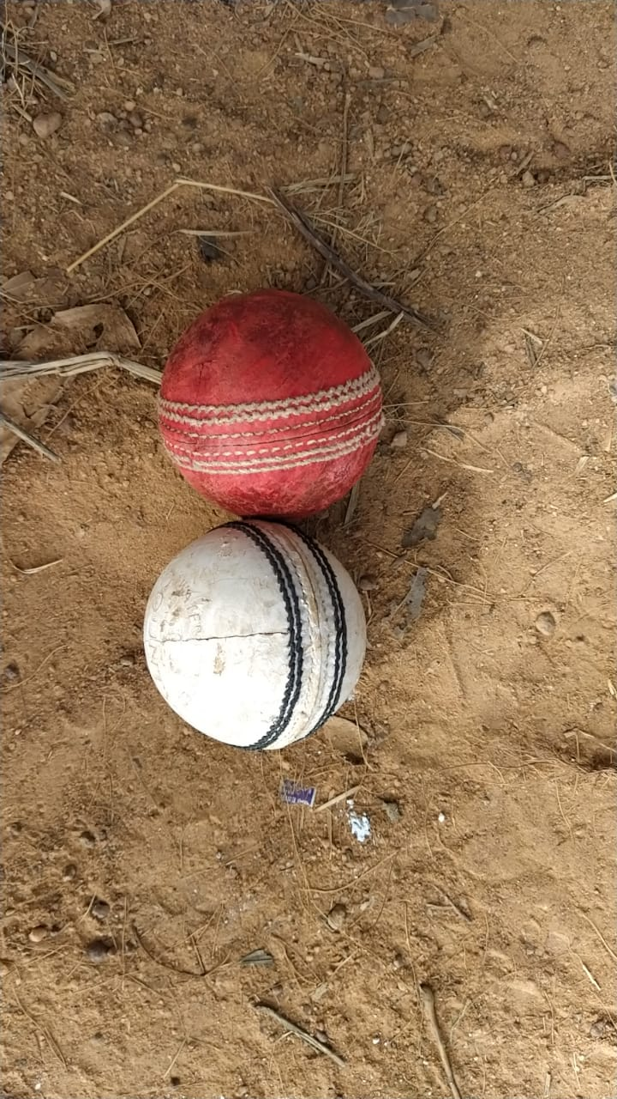

**Fig.1.9**

- original image of two balls with a different colored background.

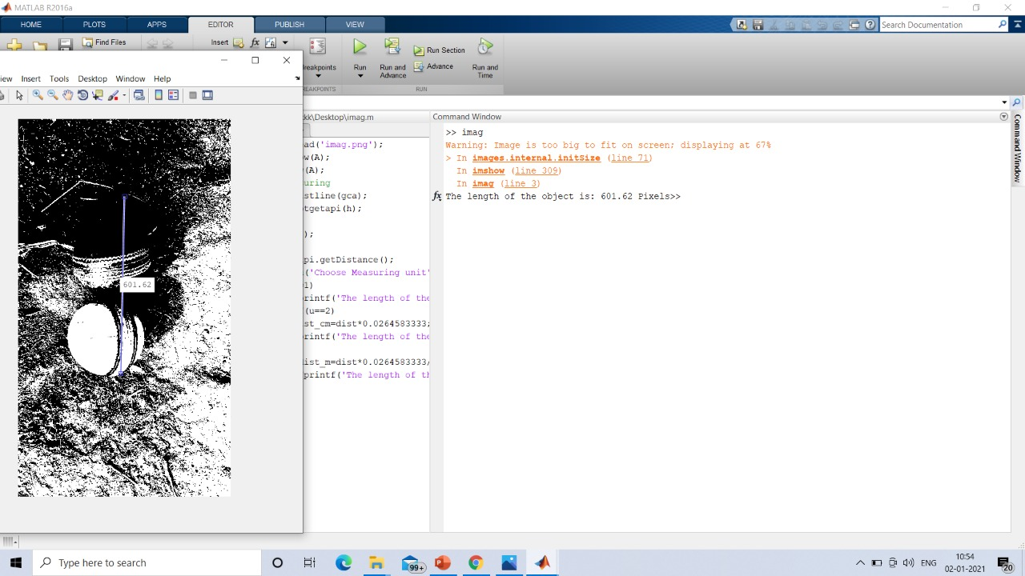

**Fig.2.0**

- measurement of the required blob in pixels.

Length from one end of the ball to the other end is = 601.62 pixels.

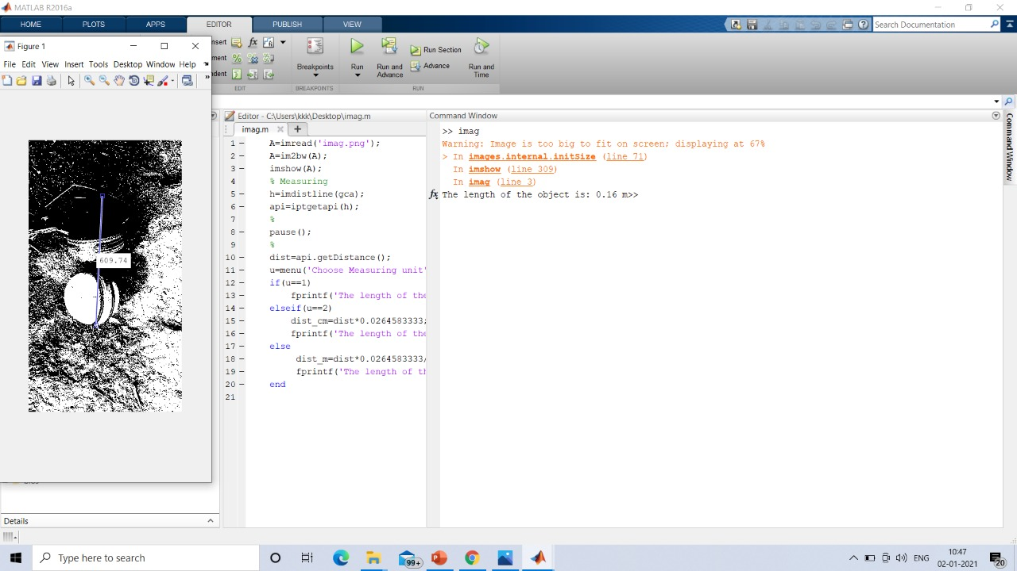

**Fig.2.1**

- measurement of required blob in meters.

Length from one end of the ball to the other end is = 0.16m.

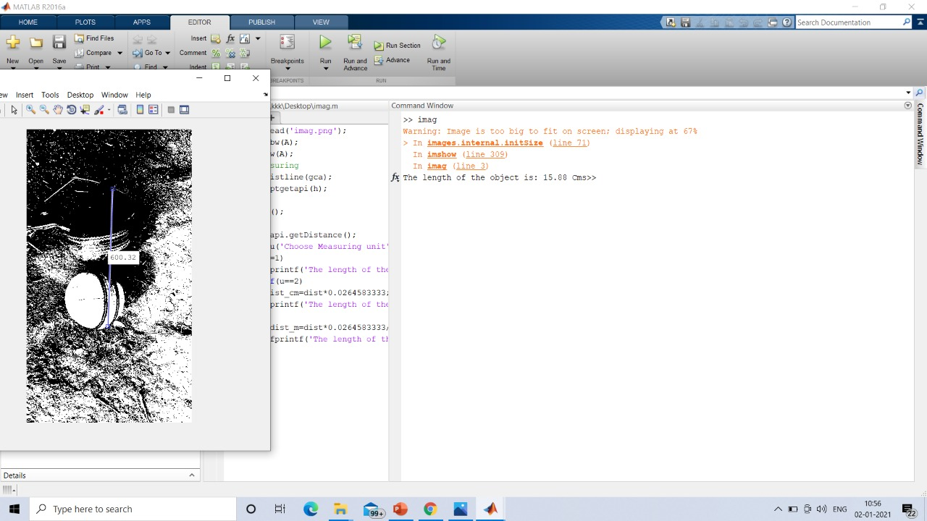

**Fig.2.2**

- measurement of required of blob in cm. (15.88cm).

* The black blob is our desired object.
* The length of balls from one end of the ball to the other end is 16 cm measured physically.
* Length of the blob from the output screenshot is 15.88 cm.
* Therefore here we can conclude that the code is working fine and the output obtained is correct, the measurements are approximately equal.

**CHAPTER 07**

**ADVANTAGES AND APPLICATIONS**

**Advantages of the project:**

* Objects make it easy to measure the dimensions of large objects.

**Applications of the project:**

* Software provides digital watermarks that enable copyright to various software.
* An Object extraction from an image.
* Digital watermarking.
* Medical imaging.
* Tracking objects.

**CHAPTER 08**

**CONCLUSION AND FUTURE SCOPE**

**Conclusion:**

* Object The simple matlab code suggests finding the length of an object in different dimensions (pixels, cm, m).
* The block diagram can be easily understood to better understand the code.
* Purpose Matlab is widely used for a variety of purposes because it is easy to use and easy to understand.
* And this project is very useful for measuring the length of various objects large and wide.

**Future scope:**

* To make the project more interesting, we can use different codes to find different physical parameters (weight, depth, etc.) of an object.

**REFERENCES**

1. <https://r.search.yahoo.com/_ylt=AwrPiBRW0.JfEEkA30W7HAx.;_ylu=Y29sbwNzZzMEcG9zAzcEdnRpZAMEc2VjA3Ny/RV=2/RE=1608729558/RO=10/RU=https%3a%2f%2fwww.mathworks.com%2fdiscovery%2fimage-recognition-matlab.html/RK=2/RS=_nowPq1Zrtuk7zNDvTstxeeDJZk->
2. <https://r.search.yahoo.com/_ylt=AwrPhSrO1eJfRgEAhxO7HAx.;_ylu=Y29sbwNzZzMEcG9zAzIEdnRpZAMEc2VjA3Ny/RV=2/RE=1608730190/RO=10/RU=https%3a%2f%2fwww.electronicsforu.com%2felectronics-projects%2fimage-processing-using-matlab-part-1/RK=2/RS=B4oKo3j_bFuaEDe_uyuarnjDwxE->
3. <https://r.search.yahoo.com/_ylt=AwrwIQZc1.JfxXEAHXe7HAx.;_ylu=Y29sbwNzZzMEcG9zAzgEdnRpZAMEc2VjA3Ny/RV=2/RE=1608730588/RO=10/RU=https%3a%2f%2fin.mathworks.com%2fhelp%2ffusion%2fref%2firsensor-system-object.html/RK=2/RS=ekkDqy.f1DuNRctp5rOO0YGWZ6g->
4. <https://r.search.yahoo.com/_ylt=AwrwIQZc1.JfxXEAH3e7HAx.;_ylu=Y29sbwNzZzMEcG9zAzkEdnRpZAMEc2VjA3Ny/RV=2/RE=1608730588/RO=10/RU=https%3a%2f%2fwww.guidingtech.com%2f56532%2fmeasure-size-of-images-pixels-pc%2f/RK=2/RS=Ho0gawt5qBoNkNMvgWeChjC6hto->
5. <https://r.search.yahoo.com/_ylt=AwrPiBXw2OJfPzgAkx.7HAx.;_ylu=Y29sbwNzZzMEcG9zAzEwBHZ0aWQDBHNlYwNzcg--/RV=2/RE=1608730992/RO=10/RU=https%3a%2f%2fhelpx.adobe.com%2fphotoshop%2fusing%2fmeasurement.html/RK=2/RS=6EhJpP.JoLp0b.jagLNiU.MygHY->
6. <https://r.search.yahoo.com/_ylt=AwrPhmsn2.JfRhAArD67HAx.;_ylu=Y29sbwNzZzMEcG9zAzQEdnRpZAMEc2VjA3Ny/RV=2/RE=1608731559/RO=10/RU=https%3a%2f%2fwww.ijcaonline.org%2farchives%2fvolume161%2fnumber8%2fgoel-2017-ijca-913254.pdf/RK=2/RS=wg6XmU4QPKW5.ONjpqbHBgwVVaU->
7. <https://r.search.yahoo.com/_ylt=AwrPhmsn2.JfRhAAsj67HAx.;_ylu=Y29sbwNzZzMEcG9zAzgEdnRpZAMEc2VjA3Ny/RV=2/RE=1608731559/RO=10/RU=https%3a%2f%2fwww.apriorit.com%2fdev-blog%2f599-ai-for-image-processing/RK=2/RS=dULMxTsIuw38LCJA9dw4CmANZhU->
8. <https://r.search.yahoo.com/_ylt=AwrPg3Qx3OJfQCEAYAq7HAx.;_ylu=Y29sbwNzZzMEcG9zAzEEdnRpZAMEc2VjA3Ny/RV=2/RE=1608731825/RO=10/RU=https%3a%2f%2fwww.electronicsforu.com%2felectronics-projects%2fsoftware-projects-ideas%2fimage-processing-using-matlab/RK=2/RS=28EnREdiHOopMPCwK2nHCKbXE3o->

**APPENDIX**

**MATLAB CODE:**

A=imread('images.png');

A=im2bw(A);

imshow(A);

% Measuring

h=imdistline(gca);

api=iptgetapi(h);

%

pause();

%

dist=api.getDistance();

u=menu('Choose Measuring unit','Pixels','Centimeters','Meters');

if(u==1)

fprintf('The length of the object is: %0.2f Pixels',dist)

elseif(u==2)

dist_cm=dist*0.0264583333;

fprintf('The length of the object is: %0.2f Cms',dist_cm)

else

dist_m=dist*0.0264583333/100;

fprintf('The length of the object is: %0.2f Cms',dist_m)

end